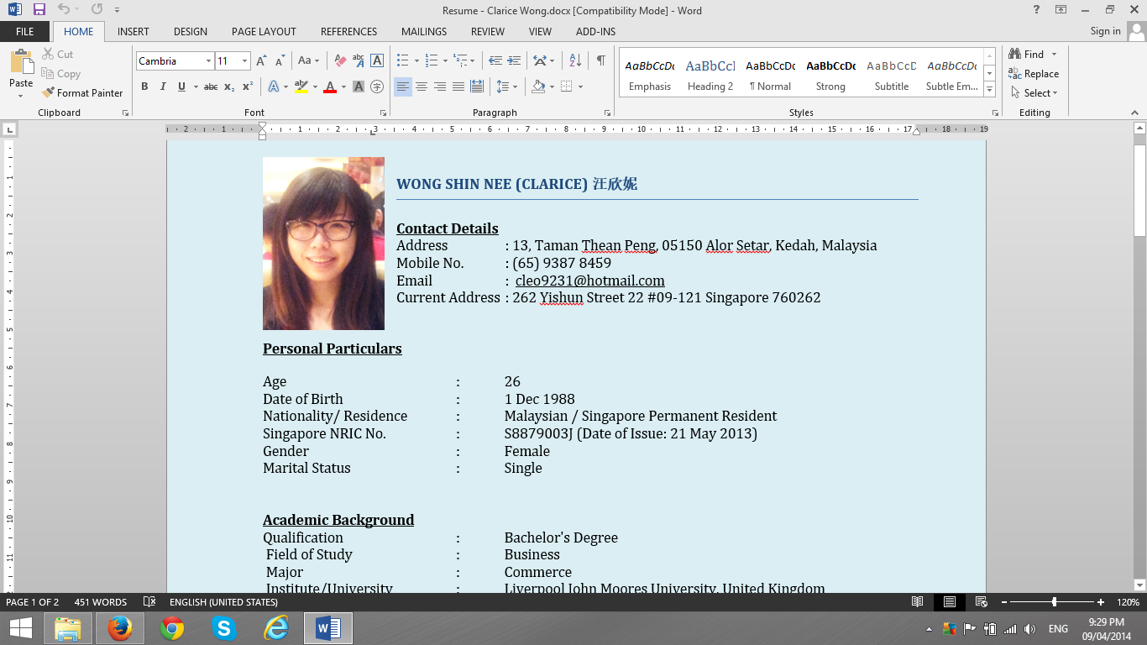

**WONG SHIN NEE (CLARICE) 汪欣妮**

**Contact Details**

Address : 13, Taman Thean Peng, 05150 Alor Setar, Kedah, Malaysia

Mobile No. : (65) 9387 8459

Email : [cleo9231@hotmail.com](mailto:cleo9231@hotmail.com)

Current Address : 262 Yishun Street 22 #09-121 Singapore 760262

**Personal Particulars**

Age : 26

Date of Birth : 1 Dec 1988

Nationality/ Residence : Malaysian / Singapore Permanent Resident

Singapore NRIC No. : S8879003J (Date of Issue: 21 May 2013)

Gender : Female

Marital Status : Single

**Academic Background**

Qualification : Bachelor's Degree

Field of Study : Business

Major : Commerce

Institute/University : Liverpool John Moores University, United Kingdom

Grade : With Honour, Class II, Division I

Graduation Date : 19 Feb 2011

Qualification : Advanced Diploma

Field of Study : Business Management

Major : Business Management cum ICSA

Institute/University : Tunku Abdul Rahman College (TARC), Malaysia

CGPA : 3.25/4

Graduation Date : 13 Nov 2010

Professional Certificate : The Malaysian Institute of Chartered Secretaries and Administrators studentship since 2008

(One paper more to obtain MAICSA membership, estimate completion period is Dec 2014)

**Vocational Certificates**

2013 Certificate of Completion issued by NTUC LearningHub Pte Ltd for Visual Communication using Adobe Photoshop CS5

Certificate of Adobe Certified Associate – Visual Communication using Adobe Photoshop CS5 issued by Adobe

2012 Certificate of Achievement issued by Singapore Academy of Law for elitigation of user module and probate module

**Working Experiences**

|  |  |
| --- | --- |
| Feb 2011 – July 2013  Company Name:  Job Description:  Last drawn salary:  Reason of leaving: | **Legal Secretary Grade II**  David Chong and Co cum Portcullis TrustNet (Singapore) Pte Ltd  Assist lawyers in e-filing, draft agreements, due-diligence check, invoicing, prepare resolutions and etc.  SGD 2700 per month  would like to pursue my career in corporate secretarial industry |

|  |  |
| --- | --- |
| 25 August 2013 - current  Company Name:  Job Description:  Last drawn salary:  Reason of leaving: | **Corporate Secretarial Assistant**  LX Management Consultancy Pte. Ltd.  E-filing with ACRA, IRAS, preparing resolutions, draft reply to clients’ queries, XBRL, update database, mail redirection, invoicing and etc.  SGD 3000 per month  would like to relocate and increase learning opportunity |

**Skills**

Microsoft Offices, UBS, Secretary 2000, Legalpac, Electronic Filing System, Elitigation, Photoshop CS5 OMIS database (In-house Information System for Corporate Secretarial)

**Languages**

(Proficiency: 0=Poor - 10=Excellent)

|  |  |  |
| --- | --- | --- |
| **Language** | **Spoken** | **Written** |
| Chinese | 8 | 8 |
| English | 7 | 7 |
| Malay | 5 | 5 |
| Cantonese | 7 | 5 |
| Hokkien | 8 | 5 |

**Job Preferences**

Expected Monthly Salary : SGD 3000

Willing to Travel : Yes

Willing to Relocate : Yes

Possess Own Transport : No

Date of Availability : One Month Notice

**References**

Name : Ms Lee Whee Tin / Rosa Koo

Relationship : Superior

Position : Advocate & Solicitor / Legal Counsel

Company : David Chong & Co. / Portcullis TrustNet (Singapore) Pte Ltd

Telephone : +65 – 6496 0510 / +65 – 6496 0511